**PRACTICAL-8(A)**

**AIM:**

Design simple tcl script for transferring FTP & CBR traffic in Wireless topology of 6 nodes using NS-2

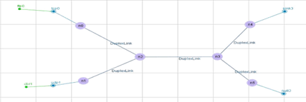

**ftp0:- (Both node with ftp)**

Packet Size: 1000

Rate: 1

Interval: 150

**cbr0:- (Both node with cbr)**

Packet Size: 1500

Rate: 0.05

Interval: 150

**THEORY:**

* Tcl is a general purpose multi-paradigm system programming language.
* It is a scripting language that aims at providing the ability for applications to communicate with each other.
* On the other hand, Tk is a cross platform widget toolkit used for building GUI in many languages.
* This tutorial covers various topics ranging from the basics of the Tcl/Tk to its scope in various applications.

**TOPOLOGY:**

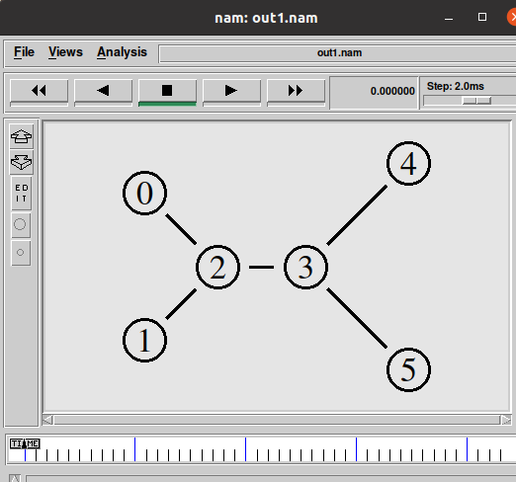

**PROGRAM CODE:**

**set sn [new Simulator]**

**$sn color 1 Blue**

**$sn color 2 Red**

**set nt [open out1.nam w]**

**$sn namtrace-all $nt**

**set tr [open out1.tr w]**

**$sn trace-all $tr**

**proc finish {} {**

**global sn nt tr**

**$sn flush-trace**

**close $nt**

**close $tr**

**exec nam out1.nam &**

**exit 0**

**}**

**set n0 [$sn node]**

**set n1 [$sn node]**

**set n2 [$sn node]**

**set n3 [$sn node]**

**set n4 [$sn node]**

**set n5 [$sn node]**

**$sn duplex-link $n0 $n2 10Mb 10ms RED**

**$sn duplex-link $n1 $n2 10Mb 10ms RED**

**$sn duplex-link $n2 $n3 5Mb 6ms RED**

**$sn duplex-link $n3 $n4 10Mb 20ms RED**

**$sn duplex-link $n3 $n5 10Mb 20ms RED**

**$sn queue-limit $n3 $n4 10**

**$sn duplex-link-op $n0 $n2 orient right-down**

**$sn duplex-link-op $n1 $n2 orient right-up**

**$sn duplex-link-op $n2 $n3 orient right**

**$sn duplex-link-op $n3 $n4 orient right-up**

**$sn duplex-link-op $n3 $n5 orient right-down**

**$sn duplex-link-op $n2 $n3 queuePos 0.5**

**$sn duplex-link-op $n3 $n4 queuePos 0.5**

**set tcp [new Agent/TCP]**

**$tcp set class_ 1**

**$sn attach-agent $n0 $tcp**

**set sink [new Agent/TCPSink]**

**$sn attach-agent $n4 $sink**

**$sn connect $tcp $sink**

**$tcp set fid_ 2**

**set ftp [new Application/FTP]**

**$ftp attach-agent $tcp**

**$ftp set type_ FTP**

**$ftp set packet_size_ 1000**

**$ftp set packet_size_ 1mb**

**set udp [new Agent/UDP]**

**$sn attach-agent $n1 $udp**

**set null [new Agent/Null]**

**$sn attach-agent $n4 $null**

**$sn connect $udp $null**

**$udp set fid_ 1**

**set cbr [new Application/Traffic/CBR]**

**$cbr attach-agent $udp**

**$cbr set type_ CBR**

**$cbr set packet_size_ 1500**

**$cbr set rate_ 0.05mb**

**$cbr set random_ false**

**$sn at 0.2 "$cbr start"**

**$sn at 0.8 "$ftp start"**

**$sn at 4.0 "$ftp stop"**

**$sn at 4.5 "$cbr stop"**

**$sn at 5.0 "finish"**

**$sn run**

**OUTPUT:**

**Network Topology:**



**PRACTICAL-8(B)**

**AIM:**

To demonstrate the use of AWK script with NS2 trace file of scenario A. Find Out

Throughput, Packet delivery ratio, Number Drop Packets for all Queues.

**THEORY:**

**AWK Script:**

* AWK is a high-level programming language which is used to process text files, named after its three original author's names:

A: Alfred

W: Peter Weinberger

K: Brian Kernighan

* AWK Scripts are very good in processing the data from the log (trace files) which we get from NS2. If you want to process the trace file manually.

**AWK PROGRAM STRUCTURE:**

* AWK program structure contains mainly three parts;

1. Begin

2. Content

3. End

**BEGIN:**

* Begin deals with what to be executed prior to text file processing, normally which is used to initialize variable values or constants.

**CONTENT:**

* Script which process the text file. In this part, AWK moves lines by lines (i.e., records by records) and executes the <actionSet> if the current line match with the pattern. The actions repeat until AWK reaches the end of the file.

**END:**

* This part explains what to be executed after the text file processing ie. what to print on the terminal or to show output in terminal.

**EXECUTION:**

* AWK has two types of execution;

1) Plain Execution.

2) Match and Execute.

* **Plain Execution:** 
  + Simply AWK statements.
* **Match and execute:**
  + The second type of execution is “Match and Execute”, when executes plain execution statements only if the current line (of the input text file) matches with a predefined pattern.
  + The pattern can be either:

1. Logical Expression

2. Regular Expression.

**PROGRAM CODE:**

BEGIN {

start_time=0

finish_time=0

get_start_time=0

throughput=0

latency=0

file_size=0

}

{

if ($1 == "r" && $4== 4)

{ print($1 , $4 , file_size)

file_size+=$6

if (get_start_time == 0)

{

get_start_time =1

start_time=$2

}

finish_time =$2

}

}

END{

latency=finish_time-start_time

throughput=(file_size*8)/latency

printf ("%f\n", latency)

printf ("%f\n", throughput) }

BEGIN{

drop=0

receive=0}

{if($1=="d"){

drop++;}

else($1=="r")

{receive++;}}

END{

printf("\npacket dropped= %d",drop)

#printf("\npacket received= %d",receive)

printf("\npacket ratio= %f",receive/(drop+receive)) }

**CONCLUSION:**

* In this practical, we learned about TCL script
* We also learnt about AWK script.